S2 Appendix. Schematic flowchart for the study design with exclusion criteria.

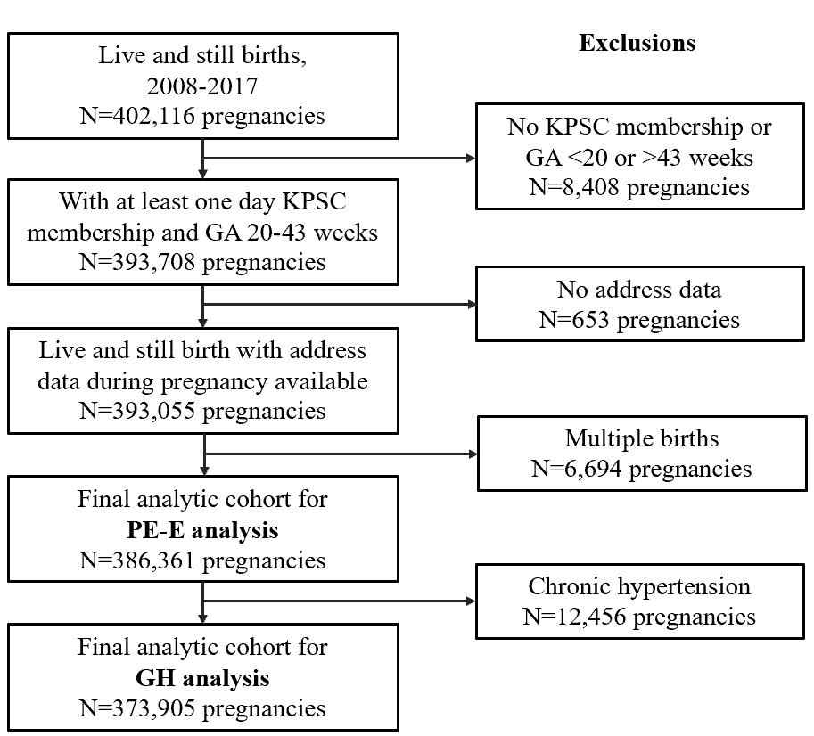

KPSC, Kaiser Permanente Southern California; GA, gestational age; GH, gestational hypertension; PE-E, preeclampsia-eclampsia (with any one of the following: preeclampsia, preeclampsia superimposed upon chronic hypertension, or eclampsia).

